FINAL PROJECT

INTRODUCTION:
The game has a visual design that players can interact with, instead of just text in the console. The game will show the Ludo board, dice, and player pieces on a screen, making it more fun and user-friendly. Players can use a mouse or keyboard to roll the dice and move their pieces.

LIBRARIES:

- <iostream>
- <string>
- <conio.h>
- <stdlib.h>
- <windows.h>
- <time.h>

FUNCTIONALITY:
4 players to roll a dice, take decisions and move the pawn based on the outcome of the dice on a well-designed graphical user interface.

CONCEPTS USED:

Classes

- PLAYER: Manages individual player data, including their name, tokens, colors, and positions.
- SHOW: Handles the display and setup of the game board and players.
- START: Controls the game's flow, managing player turns, dice rolls, and the overall game state.

Inheritance

Inheritance occurs between the START class and the SHOW class, allowing START to inherit functionality from SHOW. This design choice of using inheritance helps us write code that can be reused, keeps things organized, makes it easy to add new features, and allows us to manage the game more effectively. It helps everyone involved whether they are writing the code or playing the game have a better experience.

Composition

GameBoard in Start:
In the Start class, there is an instance of the GameBoard class. This indicates composition because Start contains a GameBoard object. The Start class can use the methods and properties of the GameBoard class to manage the game board.

Players in Start:
The Start class also has a vector of Player objects. This means that Start is composed of multiple Player instances. Each Player object holds information about a player, such as their name and score. This allows Start to manage multiple players within the game.

UML DIAGRAM:
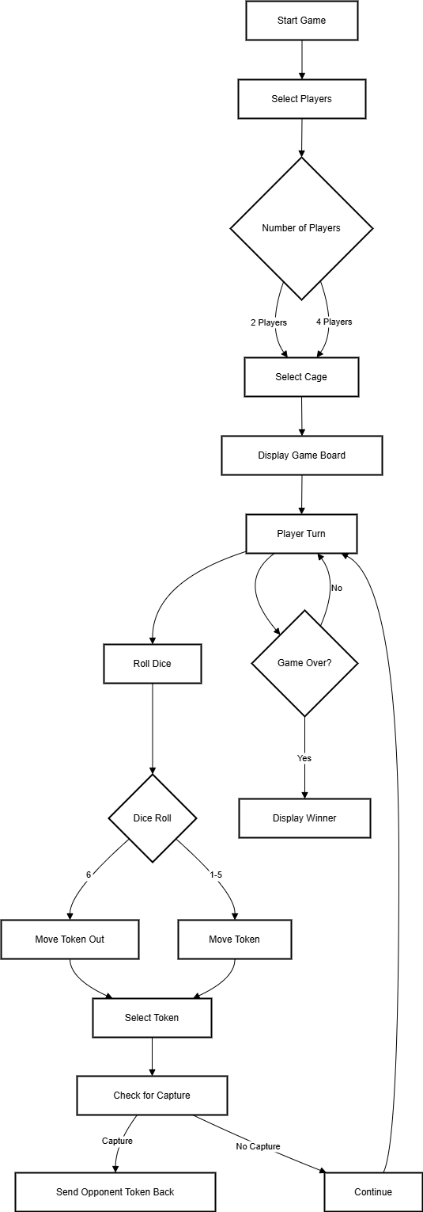

CODE:
#include<iostream> #include<stdlib.h> #include<windows.h> #include<time.h>

#define RAND_MAX 7
#define MAX_STEP 61
#define No_Of_Objects 4 using namespace std;
class Player {
int c[4] = { 159,111,79,175 };
char first_player[4] = { '1','2','3','4' };
char* location[4] = { nullptr,nullptr,nullptr,nullptr }; int Count[4] = { -1,-1,-1,-1 };
int stepCount[4] = { -1,-1,-1,-1 };
bool insideStep[4] = { false,false,false,false }; string name = " ";
int pin; public:
void setName(string name) { this->name = name;
}
void getName() {
cout << " " << name << " ";
}

string checkName() { return name;
}

int getColor(int activePlayer) { return c[activePlayer];
}
char getIcon(int icon) { return first_player[icon];
}

char* getLocation(int address_no) { return (location[address_no]);
}

void setLocation(int address_no, char* locate)
{

location[address_no] = locate;
}

void setLocation(int address_no) { char p;
switch (address_no) { case 0: p = '1';
break;
case 1: p = '2'; break;
case 2: p = '3'; break;
case 3: p = '4'; break;
}
*location[address_no] = p;
}
void setLocation(int address_no, char p) {
*location[address_no] = p;
}

int getStepCount(int address_no) { return (stepCount[address_no]);
}

void setStepCount(int address_no, int step) { stepCount[address_no] = step;
}

int getCount(int address_no) { return (Count[address_no]);
}

void setCount(int address_no, int step) { Count[address_no] = step;
}
bool checkInsideStatus(int address_no) { return insideStep[address_no];
}

void checkInsideStatus(int address_no, bool state) { insideStep[address_no] = state;
}
};

class show {
int color[4] = { 121,118,116,122 };
int player;
int cage_number;

void set4Players()
{
(p[0].getStepCount(0) == -1) ? lodo[3][3] = '1' : lodo[3][3] = 'ß';
(p[0].getStepCount(1) == -1) ? lodo[3][4] = '2' : lodo[3][4] = 'ß';
(p[0].getStepCount(2) == -1) ? lodo[4][3] = '3' : lodo[4][3] = 'ß';
(p[0].getStepCount(3) == -1) ? lodo[4][4] = '4' : lodo[4][4] = 'ß';
(p[1].getStepCount(0) == -1) ? lodo[3][12] = '1' : lodo[3][12] = 'ß';
(p[1].getStepCount(1) == -1) ? lodo[3][13] = '2' : lodo[3][13] = 'ß';
(p[1].getStepCount(2) == -1) ? lodo[4][12] = '3' : lodo[4][12] = 'ß';
(p[1].getStepCount(3) == -1) ? lodo[4][13] = '4' : lodo[4][13] = 'ß';
(p[2].getStepCount(0) == -1) ? lodo[12][12] = '1' : lodo[12][12] = 'ß';
(p[2].getStepCount(1) == -1) ? lodo[12][13] = '2' : lodo[12][13] = 'ß';
(p[2].getStepCount(2) == -1) ? lodo[13][12] = '3' : lodo[13][12] = 'ß';
(p[2].getStepCount(3) == -1) ? lodo[13][13] = '4' : lodo[13][13] = 'ß';
(p[3].getStepCount(0) == -1) ? lodo[12][3] = '1' : lodo[12][3] = 'ß';
(p[3].getStepCount(1) == -1) ? lodo[12][4] = '2' : lodo[12][4] = 'ß';
(p[3].getStepCount(2) == -1) ? lodo[13][3] = '3' : lodo[13][3] = 'ß';
(p[3].getStepCount(3) == -1) ? lodo[13][4] = '4' : lodo[13][4] = 'ß';
}

void set2Players()
{

'ß';

'ß';
'ß';

'ß';
(p[0].getStepCount(0) == -1) ? (cage_number == 2) ? lodo[3][3] = 'ß' : lodo[3][3] = '1' : lodo[3][3] =

(p[0].getStepCount(1) == -1) ? (cage_number == 2) ? lodo[3][4] = 'ß' : lodo[3][4] = '2' : lodo[3][4] =

(p[0].getStepCount(2) == -1) ? (cage_number == 2) ? lodo[4][3] = 'ß' : lodo[4][3] = '3' : lodo[4][3] =

(p[0].getStepCount(3) == -1) ? (cage_number == 2) ? lodo[4][4] = 'ß' : lodo[4][4] = '4' : lodo[4][4] =

(p[1].getStepCount(0) == -1) ? (cage_number == 1) ? lodo[3][12] = 'ß' : lodo[3][12] = '1' :

lodo[3][12] = 'ß';
(p[1].getStepCount(1) == -1) ? (cage_number == 1) ? lodo[3][13] = 'ß' : lodo[3][13] = '2' : lodo[3][13] = 'ß';
(p[1].getStepCount(2) == -1) ? (cage_number == 1) ? lodo[4][12] = 'ß' : lodo[4][12] = '3' : lodo[4][12] = 'ß';
(p[1].getStepCount(3) == -1) ? (cage_number == 1) ? lodo[4][13] = 'ß' : lodo[4][13] = '4' : lodo[4][13] = 'ß';
(p[2].getStepCount(0) == -1) ? (cage_number == 2) ? lodo[12][12] = 'ß' : lodo[12][12] = '1' : lodo[12][12] = 'ß';
(p[2].getStepCount(1) == -1) ? (cage_number == 2) ? lodo[12][13] = 'ß' : lodo[12][13] = '2' : lodo[12][13] = 'ß';
(p[2].getStepCount(2) == -1) ? (cage_number == 2) ? lodo[13][12] = 'ß' : lodo[13][12] = '3' : lodo[13][12] = 'ß';
(p[2].getStepCount(3) == -1) ? (cage_number == 2) ? lodo[13][13] = 'ß' : lodo[13][13] = '4' : lodo[13][13] = 'ß';
(p[3].getStepCount(0) == -1) ? (cage_number == 1) ? lodo[12][3] = 'ß' : lodo[12][3] = '1' : lodo[12][3] = 'ß';
(p[3].getStepCount(1) == -1) ? (cage_number == 1) ? lodo[12][4] = 'ß' : lodo[12][4] = '2' : lodo[12][4] = 'ß';

(p[3].getStepCount(2) == -1) ? (cage_number == 1) ? lodo[13][3] = 'ß' : lodo[13][3] = '3' : lodo[13][3] = 'ß';
(p[3].getStepCount(3) == -1) ? (cage_number == 1) ? lodo[13][4] = 'ß' : lodo[13][4] = '4' : lodo[13][4] = 'ß';
}
public:

char lodo[17][17]; char* ludo[56] = {
&lodo[7][2],&lodo[7][3],&lodo[7][4],&lodo[7][5],&lodo[7][6],&lodo[7][7],&lodo[6][7],&lodo[5][7],&l
odo[4][7],&lodo[3][7],&lodo[2][7],&lodo[1][7],&lodo[1][8],&lodo[1][9],&lodo[2][9],&lodo[3][9],&lod
o[4][9],&lodo[5][9],&lodo[6][9],&lodo[7][9],&lodo[7][10],&lodo[7][11],&lodo[7][12],&lodo[7][13],&l
odo[7][14],&lodo[7][15],&lodo[8][15],&lodo[9][15],&lodo[9][14],&lodo[9][13],&lodo[9][12],&lodo[9][
11],&lodo[9][10],&lodo[9][9],&lodo[10][9],&lodo[11][9],&lodo[12][9],&lodo[13][9],&lodo[14][9],&lo
do[15][9],&lodo[15][8],&lodo[15][7],&lodo[14][7],&lodo[13][7],&lodo[12][7],&lodo[11][7],&lodo[10][
7],&lodo[9][7],&lodo[9][6],&lodo[9][5],&lodo[9][4],&lodo[9][3],&lodo[9][2],&lodo[9][1],&lodo[8][1], &lodo[7][1] };
char* insideLudo[4][7] = {
{&lodo[8][2],&lodo[8][3],&lodo[8][4],&lodo[8][5],&lodo[8][6],&lodo[8][7],&lodo[8][8]},{&lodo[2][8],
&lodo[3][8],&lodo[4][8],&lodo[5][8],&lodo[6][8],&lodo[7][8],&lodo[8][8]},{&lodo[8][14],&lodo[8][13
],&lodo[8][12],&lodo[8][11],&lodo[8][10],&lodo[8][9],&lodo[8][8]},{&lodo[14][8],&lodo[13][8],&lod o[12][8],&lodo[11][8],&lodo[10][8],&lodo[9][8],&lodo[8][8]} };
Player* p;

int numOfPlayers() { return player;
}

void numOfPlayers(int byDefault) { player = byDefault;
}
int cageNumber() { return cage_number;
}

void logo()
{
system("cls"); SetConsoleTextAttribute(GetStdHandle(STD_OUTPUT_HANDLE), 240); cout << "\n\n\n"; SetConsoleTextAttribute(GetStdHandle(STD_OUTPUT_HANDLE), 241); cout << "\t\t\t ÛÛ ÛÛ ÛÛ ÛÛÛÛÛÜ ÜÛÛÛÜ \n"; SetConsoleTextAttribute(GetStdHandle(STD_OUTPUT_HANDLE), 244); cout << "\t\t\t ÛÛ ÛÛ ÛÛ ÛÛ ßÛÜ ÜÛß ßÛÜ \n"; SetConsoleTextAttribute(GetStdHandle(STD_OUTPUT_HANDLE), 246); cout << "\t\t\t ÛÛ ÛÛ ÛÛ ÛÛ ÛÛ ÛÛ ÛÛ \n"; SetConsoleTextAttribute(GetStdHandle(STD_OUTPUT_HANDLE), 252); cout << "\t\t\t ÛÛ ßÛÜ ÜÛß ÛÛ ÜÛß ßÛÜ ÜÛß \n"; SetConsoleTextAttribute(GetStdHandle(STD_OUTPUT_HANDLE), 249);

cout << "\t\t\t ÛÛÛÛÛÛ ßÛÛÛÛÛß ÛÛÛÛÛß ßÛÛÛß \n"; SetConsoleTextAttribute(GetStdHandle(STD_OUTPUT_HANDLE), 240);
}

int players()
{
system("cls"); logo();
int num_of_player; cout << "\n\n";
cout << "====================================== WELCOME TO LUDO
==========================================\n\n";
cout << "================================= SELECT NUMBER OF PLAYERS
======================================\n\n";
cout << "\t\t\t\t\t> 2 Players\n\n"; cout << "\t\t\t\t\t> 4 Players\n\n\n"; cout <<
"==========================================================================
=======================\n\n";
cout << "\t\t\tEnter Your Choice:: "; cin >> num_of_player;
if (num_of_player == 2 || num_of_player == 4) { player = num_of_player;
}
else {
SetConsoleTextAttribute(GetStdHandle(STD_OUTPUT_HANDLE), 244); cout << "\n\t\t\tPlease choose from given choices only."; SetConsoleTextAttribute(GetStdHandle(STD_OUTPUT_HANDLE), 240); cout << "\n\n\n\n\n "; system("pause");
players();
}
cout << "\n\n"; return player;
}

int selectCage()
{
int cage; ludoBoard(1); display(); cout << "\n";
cout << "================================ SELECT YOUR CAVES
==============================================\n\n";
cout << "\t\t\t [1]=> Cave 1 & Cave 3 \n"; cout << "\t\t\t [2]=> Cave 2 & Cave 4 \n\n"; cout <<
"==========================================================================
=======================\n\n";
cout << "\t\t\t Enter Your Choice:: "; cin >> cage;
if (cage != 1 && cage != 2) {

SetConsoleTextAttribute(GetStdHandle(STD_OUTPUT_HANDLE), 244); cout << "\n\t\t\tPlease choose from given choices only."; SetConsoleTextAttribute(GetStdHandle(STD_OUTPUT_HANDLE), 240); cout << "\n\n\n\t\t "; system("pause");
selectCage();
}
cage_number = cage; cout << "\n\n"; return cage_number;
}
void ludoBoard(int flag)
{
for (int i = 0; i < 17; i++) { for (int j = 0; j < 17; j++) {
if (((i == 3 || i == 4 || i == 12 || i == 13) && (j == 3 || j == 4 || j == 12 || j == 13)) || ((i == 7) && (j != 2 && j != 8 && j != 13 && j != 0 && j != 16)) || ((i == 9) && (j != 3 && j != 8 && j != 14 && j != 0 && j != 16)) || ((i != 3 && i != 8 && i != 14 && i != 0 && i != 16) && (j == 7)) || ((i != 2 && i != 8 && i != 13 && i != 0 && i != 16) && (j == 9)) || ((i == 8) && (j == 1 || j == 15)) || ((i == 1 || i == 15) && (j == 8)))
lodo[i][j] = 'ß';
else if ((i == 9 && j == 3) || (i == 3 && j == 7) || (i == 7 && j == 13) || (i == 13 && j == 9)) lodo[i][j] = 'ß';
else if ((i == 7 && j == 2) || (i == 2 && j == 9) || (i == 9 && j == 14) || (i == 14 && j == 7)) lodo[i][j] = 'ß';
else if ((i == 8 && (j == 2 || j == 3 || j == 4 || j == 5 || j == 6 || j == 7)) || ((i == 2 || i == 3 || i == 4
|| i == 5 || i == 6 || i == 7) && j == 8) || (i == 8 && (j == 14 || j == 13 || j == 12 || j == 11 || j == 10 || j == 9)) || ((i == 14 || i == 13 || i == 12 || i == 11 || i == 10 || i == 9) && j == 8))
lodo[i][j] = 'ß';
else if (i == 8 && j == 8) lodo[i][j] = 'ß';
else
lodo[i][j] = ' ';
}
}
if (flag == 1) {
lodo[1][3] = '1'; lodo[1][13] = '2'; lodo[15][13] = '3'; lodo[15][3] = '4';
}
}

void display()
{
if (player == 4) set4Players();
else
set2Players(); system("cls"); cout << "\n";
if (p[0].getStepCount(0) == 61 || p[0].getStepCount(1) == 61 || p[0].getStepCount(2) == 61 || p[0].getStepCount(3) == 61 || p[1].getStepCount(0) == 61 || p[1].getStepCount(1) == 61 || p[1].getStepCount(2) == 61 || p[1].getStepCount(3) == 61 || p[2].getStepCount(0) == 61 ||

p[2].getStepCount(1) == 61 || p[2].getStepCount(2) == 61 || p[2].getStepCount(3) == 61 || p[3].getStepCount(0) == 61 || p[3].getStepCount(1) == 61 || p[3].getStepCount(2) == 61 || p[3].getStepCount(3) == 61) {
for (int i = 0; i < 4; i++) {
cout << "\n\t\t "; p[i].getName(); for (int j = 0; j < 4; j++) {
if (p[i].getStepCount(j) == 61) { cout << " ";
SetConsoleTextAttribute(GetStdHandle(STD_OUTPUT_HANDLE), p[i].getColor(i)); cout << " " << j + 1; SetConsoleTextAttribute(GetStdHandle(STD_OUTPUT_HANDLE), 240);
}
}
cout << "\n";
}
}
cout << "\n\n";
for (int i = 0; i < 17; i++) { cout << "\t\t\t";
for (int j = 0; j < 17; j++) {
if ((i == 0 || j == 0 || i == 16 || j == 16))
{
SetConsoleTextAttribute(GetStdHandle(STD_OUTPUT_HANDLE), 80); cout << " " << lodo[i][j];
}
else if (i == 8 && j == 8)
{
SetConsoleTextAttribute(GetStdHandle(STD_OUTPUT_HANDLE), 117); cout << " " << lodo[i][j];
}
else if (p[0].getLocation(0) == &lodo[i][j] || p[0].getLocation(1) == &lodo[i][j] || p[0].getLocation(2) == &lodo[i][j] || p[0].getLocation(3) == &lodo[i][j])
{
SetConsoleTextAttribute(GetStdHandle(STD_OUTPUT_HANDLE), 159); cout << " " << lodo[i][j];
}
else if (p[1].getLocation(0) == &lodo[i][j] || p[1].getLocation(1) == &lodo[i][j] || p[1].getLocation(2) == &lodo[i][j] || p[1].getLocation(3) == &lodo[i][j])
{
SetConsoleTextAttribute(GetStdHandle(STD_OUTPUT_HANDLE), 111); cout << " " << lodo[i][j];
}
else if (p[2].getLocation(0) == &lodo[i][j] || p[2].getLocation(1) == &lodo[i][j] || p[2].getLocation(2) == &lodo[i][j] || p[2].getLocation(3) == &lodo[i][j])
{
SetConsoleTextAttribute(GetStdHandle(STD_OUTPUT_HANDLE), 79); cout << " " << lodo[i][j];
}
else if (p[3].getLocation(0) == &lodo[i][j] || p[3].getLocation(1) == &lodo[i][j] || p[3].getLocation(2) == &lodo[i][j] || p[3].getLocation(3) == &lodo[i][j])
{

SetConsoleTextAttribute(GetStdHandle(STD_OUTPUT_HANDLE), 47); cout << " " << lodo[i][j];
}
else if ((i == 3 || i == 4 || i == 12 || i == 13) && (j == 3 || j == 4 || j == 12 || j == 13))
{
if ((i == 3 || i == 4) && (j == 3 || j == 4)) SetConsoleTextAttribute(GetStdHandle(STD_OUTPUT_HANDLE), 144);
else if ((i == 3 || i == 4) && (j == 12 || j == 13)) SetConsoleTextAttribute(GetStdHandle(STD_OUTPUT_HANDLE), 96);
else if ((i == 12 || i == 13) && (j == 12 || j == 13)) SetConsoleTextAttribute(GetStdHandle(STD_OUTPUT_HANDLE), 64);
else
SetConsoleTextAttribute(GetStdHandle(STD_OUTPUT_HANDLE), 32); cout << " " << lodo[i][j];
}
else if ((i == 7 && j == 2) || (i == 9 && j == 3) || (i == 2 && j == 9) || (i == 3 && j == 7) || (i
== 9 && j == 14) || (i == 7 && j == 13) || (i == 14 && j == 7) || (i == 13 && j == 9))
{
cout << " ";
if ((i == 7 && j == 2) || (i == 9 && j == 3)) SetConsoleTextAttribute(GetStdHandle(STD_OUTPUT_HANDLE), 249);
else if ((i == 2 && j == 9) || (i == 3 && j == 7)) SetConsoleTextAttribute(GetStdHandle(STD_OUTPUT_HANDLE), 246);
else if ((i == 9 && j == 14) || (i == 7 && j == 13)) SetConsoleTextAttribute(GetStdHandle(STD_OUTPUT_HANDLE), 244);
else if ((i == 14 && j == 7) || (i == 13 && j == 9)) SetConsoleTextAttribute(GetStdHandle(STD_OUTPUT_HANDLE), 250);
cout << lodo[i][j];
}
else if ((i == 2 || i == 3 || i == 4 || i == 5 || i == 6 || i == 7) && j == 8)
{
SetConsoleTextAttribute(GetStdHandle(STD_OUTPUT_HANDLE), color[1]); cout << " " << lodo[i][j];
}
else if (i == 8 && (j == 2 || j == 3 || j == 4 || j == 5 || j == 6 || j == 7))
{
SetConsoleTextAttribute(GetStdHandle(STD_OUTPUT_HANDLE), color[0]); cout << " " << lodo[i][j];
}
else if ((i == 14 || i == 13 || i == 12 || i == 11 || i == 10 || i == 9) && j == 8)
{
SetConsoleTextAttribute(GetStdHandle(STD_OUTPUT_HANDLE), color[3]); cout << " " << lodo[i][j];
}
else if (i == 8 && (j == 14 || j == 13 || j == 12 || j == 11 || j == 10 || j == 9))
{
SetConsoleTextAttribute(GetStdHandle(STD_OUTPUT_HANDLE), color[2]); cout << " " << lodo[i][j];
}
else if (((i == 1 || i == 6) && (j == 1 || j == 2 || j == 3 || j == 4 || j == 5 || j == 6)) || ((i == 2 || i == 3 || i == 4 || i == 5) && (j == 1 || j == 6)))

{
SetConsoleTextAttribute(GetStdHandle(STD_OUTPUT_HANDLE), 159); cout << " " << lodo[i][j];
}
else if (((i == 10 || i == 15) && (j == 1 || j == 2 || j == 3 || j == 4 || j == 5 || j == 6)) || ((i == 11 || i
== 12 || i == 13 || i == 14) && (j == 1 || j == 6)))
{
SetConsoleTextAttribute(GetStdHandle(STD_OUTPUT_HANDLE), 32); cout << " " << lodo[i][j];
}
else if (((i == 1 || i == 6) && (j == 10 || j == 11 || j == 12 || j == 13 || j == 14 || j == 15)) || ((i == 2 || i == 3 || i == 4 || i == 5) && (j == 10 || j == 15)))
{
SetConsoleTextAttribute(GetStdHandle(STD_OUTPUT_HANDLE), 96); cout << " " << lodo[i][j];
}
else if (((i == 10 || i == 15) && (j == 10 || j == 11 || j == 12 || j == 13 || j == 14 || j == 15)) || ((i
== 10 || i == 11 || i == 12 || i == 13 || i == 14 || i == 15) && (j == 10 || j == 15)))
{
SetConsoleTextAttribute(GetStdHandle(STD_OUTPUT_HANDLE), 75); cout << " " << lodo[i][j];
}
else
cout << " " << lodo[i][j]; SetConsoleTextAttribute(GetStdHandle(STD_OUTPUT_HANDLE), 240);
}
cout << "\n";
}
}
};

class start : public show { bool bonusChance = false; int activePlayer = -1;
int activePin; char dice[5][5]; int top;
bool continueGame = true; bool pass = false;
bool gatewayPass = true; bool first_time_only = true; bool notJustMode = false;
public:
int nextChance()
{
switch (numOfPlayers()) { case 4:
{
if (activePlayer == -1) return (activePlayer = 0);
else

return ((activePlayer == 3) ? activePlayer = 0 : (activePlayer++));
}
break; case 2:
{
if (cageNumber() == 1) { if (activePlayer == -1)
return (activePlayer = 0); else
return ((activePlayer == 2) ? activePlayer = 0 : (activePlayer += 2));
}
else {
if (activePlayer == -1) return (activePlayer = 1);
else
return ((activePlayer == 3) ? activePlayer = 1 : (activePlayer += 2));
}
}
break;
}
}

void startGame()
{
int num_of_player = numOfPlayers(); p = new Player[No_Of_Objects];
if (num_of_player == 2) selectCage();
logo(); ludoBoard(0); display(); play();
cout << "\n\n\n\t\t"; SetConsoleTextAttribute(GetStdHandle(STD_OUTPUT_HANDLE), 71); cout << " *** Game Over *** "; SetConsoleTextAttribute(GetStdHandle(STD_OUTPUT_HANDLE), 240); cout << "\n\n\n\t\t "; system("pause");
}

void play()
{
if (!bonusChance) nextChance();
if (p[activePlayer].checkName() == " ") { string pName;
static int que; SetConsoleTextAttribute(GetStdHandle(STD_OUTPUT_HANDLE), 250); cout << "\n\n\n\t\t\tBlank spaces in name's is not allowed.\n"; SetConsoleTextAttribute(GetStdHandle(STD_OUTPUT_HANDLE), 240); cout << "\n\t\t\tEnter Player" << (++que) << " Name : ";
cin >> pName;

p[activePlayer].setName(pName); display();
}
cout << "\n\n\t\t\t\t Turn : "; SetConsoleTextAttribute(GetStdHandle(STD_OUTPUT_HANDLE),
p[activePlayer].getColor(activePlayer)); p[activePlayer].getName();
SetConsoleTextAttribute(GetStdHandle(STD_OUTPUT_HANDLE), 240); cout << "\n\n\n\t\t > To throw dice "; system("pause");
bonusChance = false; playChance();
if (continueGame) play();
}

void playChance()
{
displayDice();

if ((top < 6) && ((p[activePlayer].getStepCount(0) == -1 || p[activePlayer].getStepCount(0) + top > MAX_STEP) && (p[activePlayer].getStepCount(1) == -1 || p[activePlayer].getStepCount(1) + top > MAX_STEP) && (p[activePlayer].getStepCount(2) == -1 || p[activePlayer].getStepCount(2) + top > MAX_STEP) && (p[activePlayer].getStepCount(3) == -1 || p[activePlayer].getStepCount(3) + top > MAX_STEP)))
gatewayPass = false;
if (((gatewayPass && (top == 6 || (top >= 1 && top <= 5 && (p[activePlayer].getLocation(0) != nullptr || p[activePlayer].getLocation(1) != nullptr || p[activePlayer].getLocation(2) != nullptr || p[activePlayer].getLocation(3) != nullptr))))))
{
selectPin(); if (pass)
{
if (top == 6) bonusChance = true;
if ((p[activePlayer].getStepCount(activePin) + top) <= 54)
{
if (top == 6)
{
if (p[activePlayer].getLocation(activePin) != nullptr)
{
placeState();
p[activePlayer].setCount(activePin, (p[activePlayer].getCount(activePin) + top) % 56); p[activePlayer].setStepCount(activePin, p[activePlayer].getStepCount(activePin) + top);
}
else
{
p[activePlayer].setCount(activePin, activePlayer * 14); p[activePlayer].setStepCount(activePin, 0);
}
p[activePlayer].setLocation(activePin, ludo[p[activePlayer].getCount(activePin)]); p[activePlayer].setLocation(activePin);
checkPlace();

}
else if (p[activePlayer].getLocation(activePin) != nullptr)
{
placeState();
p[activePlayer].setCount(activePin, (p[activePlayer].getCount(activePin) + top) % 56); p[activePlayer].setStepCount(activePin, p[activePlayer].getStepCount(activePin) + top); p[activePlayer].setLocation(activePin, ludo[p[activePlayer].getCount(activePin)]); p[activePlayer].setLocation(activePin);
checkPlace();
}
}
else
{
if (!p[activePlayer].checkInsideStatus(activePin)) { placeState(); p[activePlayer].checkInsideStatus(activePin, true); p[activePlayer].setCount(activePin, -1);
}
else
insidePlaceState();
p[activePlayer].setStepCount(activePin, p[activePlayer].getStepCount(activePin) + top); p[activePlayer].setLocation(activePin,
insideLudo[activePlayer][p[activePlayer].getStepCount(activePin) - 55]); if (p[activePlayer].getStepCount(activePin) != MAX_STEP) {
p[activePlayer].setLocation(activePin);
}
else
{
bonusChance = true; display();
SetConsoleTextAttribute(GetStdHandle(STD_OUTPUT_HANDLE), 250); cout << "\n\t\t # # Awesome!! ";
p[activePlayer].getName();
cout << "your token " << activePin + 1 << " has reached finishing square. # # " << endl; SetConsoleTextAttribute(GetStdHandle(STD_OUTPUT_HANDLE), 240);
cout << "\n\n\n\t\t "; system("pause");

if (p[activePlayer].getLocation(0) == &lodo[8][8] && p[activePlayer].getLocation(1) == &lodo[8][8] && p[activePlayer].getLocation(2) == &lodo[8][8] && p[activePlayer].getLocation(3) == &lodo[8][8])
{
continueGame = false; SetConsoleTextAttribute(GetStdHandle(STD_OUTPUT_HANDLE), 117); cout << "\n\n\t\t Congratulations";
p[activePlayer].getName();
cout << " you wins the game." << endl; return;
}
}
}
}

gatewayPass = true;
}
else {
SetConsoleTextAttribute(GetStdHandle(STD_OUTPUT_HANDLE), 244); if (!gatewayPass) {
gatewayPass = true;
if (p[activePlayer].getStepCount(0) == -1 && p[activePlayer].getStepCount(1) == -1 && p[activePlayer].getStepCount(2) == -1 && p[activePlayer].getStepCount(3) == -1)
cout << "\n\t\t Sorry!! You can open a new token only when 6 appears on the dice." << endl; else
cout << "\n\t\t This move is not possible for you." << endl;
}
else {
cout << "\n\t\tSorry!! You can open a new token only when 6 appears on the dice." << endl;
}
SetConsoleTextAttribute(GetStdHandle(STD_OUTPUT_HANDLE), 240); cout << "\n\n\n\t\t "; system("pause");
}
display();
}

void placeState()
{
if (p[activePlayer].getCount(activePin) == 0 || p[activePlayer].getCount(activePin) == 9 || p[activePlayer].getCount(activePin) == 14 || p[activePlayer].getCount(activePin) == 23 || p[activePlayer].getCount(activePin) == 28 || p[activePlayer].getCount(activePin) == 37 || p[activePlayer].getCount(activePin) == 42 || p[activePlayer].getCount(activePin) == 51) {
int f = 0;
for (int i = 1; i <= 4; i++) {
for (int pi = 1; pi <= 4; pi++) {
if (p[activePlayer].getCount(activePin) == p[(activePlayer + i) % 4].getCount((activePin +
pi) % 4)) {
if ((((activePlayer + i) % 4) == activePlayer) && (((activePin + pi) % 4) == activePin)) { if (p[activePlayer].getCount(activePin) == 0 || p[activePlayer].getCount(activePin) ==
14 || p[activePlayer].getCount(activePin) == 28 || p[activePlayer].getCount(activePin) == 42) p[activePlayer].setLocation(activePin, 'ß');
else
p[activePlayer].setLocation(activePin, 'ß');

% 4));
}
else
p[activePlayer].setLocation(activePin, p[(activePlayer + i) % 4].getIcon((activePin + pi)

f = 1;
break;
}
}

if (f == 1) break;
}
if (f == 0) p[activePlayer].setLocation(activePin, 'ß');

}
else
p[activePlayer].setLocation(activePin, 'ß');
}

void insidePlaceState()
{
int flag = 0;
for (int i = 1; i < 4; i++)
if (p[activePlayer].getStepCount(activePin) == p[activePlayer].getStepCount((activePin + i) % 4))
{
p[activePlayer].setLocation(activePin, p[activePlayer].getIcon((activePin + i) % 4)); flag = 1;
break;
}
if (flag == 0) p[activePlayer].setLocation(activePin, 'ß');
}

void checkPlace()
{
for (int plr = 0; plr < 4; plr++) { if (plr != activePlayer) {
for (int i = 0; i < 4; i++) {
if (p[activePlayer].getLocation(activePin) == p[plr].getLocation(i) && (p[activePlayer].getCount(activePin) != 0 && p[activePlayer].getCount(activePin) != 9 && p[activePlayer].getCount(activePin) != 14 && p[activePlayer].getCount(activePin) != 23 && p[activePlayer].getCount(activePin) != 28 && p[activePlayer].getCount(activePin) != 37 && p[activePlayer].getCount(activePin) != 42 && p[activePlayer].getCount(activePin) != 51))
{
SetConsoleTextAttribute(GetStdHandle(STD_OUTPUT_HANDLE), 241);
cout << "\n\t\t NOTE : Token " << i + 1 << " of"; p[plr].getName(); cout << "has been killed by token " << activePin + 1 << " of"; p[activePlayer].getName(); cout << "." << endl;
SetConsoleTextAttribute(GetStdHandle(STD_OUTPUT_HANDLE), 240); cout << "\n\n\n\t\t "; system("pause");
p[plr].setLocation(i, nullptr); p[plr].setStepCount(i, -1);
p[plr].setCount(i, -1); display(); bonusChance = true;
}
}
}
}
}

void selectPin()
{
int pin;
int invalid = 1; while (invalid) {

cout << "\n\t\tPlease select a Token : "; cin >> pin;
if (pin >= 1 && pin <= 4)
{
if (((top <= 5 && p[activePlayer].getLocation(pin - 1) != nullptr) || top == 6) && ((p[activePlayer].getStepCount(pin - 1) + top) <= MAX_STEP)) {
activePin = pin - 1; pass = true;
invalid = 0;
}
else if ((p[activePlayer].getStepCount(pin - 1) == MAX_STEP || p[activePlayer].getLocation(pin - 1) == &lodo[8][8]) && ((p[activePlayer].getLocation(pin % 4) == nullptr || p[activePlayer].getLocation(pin % 4) == &lodo[8][8]) && (p[activePlayer].getLocation((pin + 1) % 4) == nullptr || p[activePlayer].getLocation((pin + 1) % 4) == &lodo[8][8]) && (p[activePlayer].getLocation((pin + 2) % 4) == nullptr || p[activePlayer].getLocation((pin + 2) % 4) == &lodo[8][8])))
{
pass = false; SetConsoleTextAttribute(GetStdHandle(STD_OUTPUT_HANDLE), 244); cout << "\n\t\tThis move is not possible for you."; SetConsoleTextAttribute(GetStdHandle(STD_OUTPUT_HANDLE), 240); cout << "\n\n\n\t\t "; system("pause");
invalid = 0;
}
else if ((p[activePlayer].getStepCount(pin - 1) + top > MAX_STEP) && ((p[activePlayer].getLocation(pin % 4) == nullptr || p[activePlayer].getLocation(pin % 4) == &lodo[8][8]) && (p[activePlayer].getLocation((pin + 1) % 4) == nullptr || p[activePlayer].getLocation((pin + 1) % 4)
== &lodo[8][8]) && (p[activePlayer].getLocation((pin + 2) % 4) == nullptr || p[activePlayer].getLocation((pin + 2) % 4) == &lodo[8][8])))
{
pass = false; SetConsoleTextAttribute(GetStdHandle(STD_OUTPUT_HANDLE), 244); cout << "\n\t\tThis move is not possible for you."; SetConsoleTextAttribute(GetStdHandle(STD_OUTPUT_HANDLE), 240); cout << "\n\n\n\t\t "; system("pause");
invalid = 0;
}
else if ((p[activePlayer].getStepCount(pin - 1) + top > MAX_STEP) && (p[activePlayer].getStepCount(pin % 4) + top) > MAX_STEP && (p[activePlayer].getStepCount((pin + 1) % 4) + top) > MAX_STEP && (p[activePlayer].getStepCount((pin + 2) % 4) + top) > MAX_STEP)
{
pass = false; invalid = 0;
}
else {
SetConsoleTextAttribute(GetStdHandle(STD_OUTPUT_HANDLE), 244);
cout << "\n\t\tAny token out of home which is allowed to take " << top << " step can only be

selected.";

}
}

SetConsoleTextAttribute(GetStdHandle(STD_OUTPUT_HANDLE), 240);

else {
SetConsoleTextAttribute(GetStdHandle(STD_OUTPUT_HANDLE), 244); cout << "\n\t\tEnter a valid Pin!!"; SetConsoleTextAttribute(GetStdHandle(STD_OUTPUT_HANDLE), 240); cout << "\n\n\n\t\t "; system("pause");
}
}
}
void displayDice()
{
throwDice(); cout << "\n";
SetConsoleTextAttribute(GetStdHandle(STD_OUTPUT_HANDLE), 245); for (int x = 0; x < 5; x++) {
cout << "\t\t ";
for (int y = 0; y < 5; y++) {
if ((x == 0 || x == 4) || (y == 0 || y == 4)) dice[x][y] = '..';
cout << " " << dice[x][y];
}
cout << "\n";
}
emptyDice(); SetConsoleTextAttribute(GetStdHandle(STD_OUTPUT_HANDLE), 240);
}
int throwDice()
{
if (first_time_only) { srand(time(NULL)); first_time_only = false;
}
top = rand() % RAND_MAX; if (top > 0 && top < 7) {
switch (top) { case 1: {
dice[2][2] = 'Ü';
}
break;
case 2: {
dice[2][1] = 'Ü'; dice[2][3] = 'Ü';
}
break;
case 3: {
dice[1][3] = 'Ü'; dice[2][2] = 'Ü'; dice[3][1] = 'Ü';
}
break;
case 4: {
dice[1][1] = 'Ü'; dice[1][3] = 'Ü'; dice[3][1] = 'Ü'; dice[3][3] = 'Ü';
}
break;
case 5: {

dice[1][1] = 'Ü'; dice[1][3] = 'Ü'; dice[3][1] = 'Ü'; dice[3][3] = 'Ü'; dice[2][2] = 'Ü';
}
break;

'Ü';
case 6: {
dice[1][1] = 'Ü'; dice[2][1] = 'Ü'; dice[3][1] = 'Ü'; dice[1][3] = 'Ü'; dice[2][3] = 'Ü'; dice[3][3] =

}
break;
}
return top;
}
throwDice();
}
void emptyDice() {
for (int x = 0; x < 5; x++) for (int y = 0; y < 5; y++)
dice[x][y] = ' ';
}
};

int main() {
SMALL_RECT windowSize = { 0,0,90,90 }; SetConsoleWindowInfo(GetStdHandle(STD_OUTPUT_HANDLE), TRUE, &windowSize); SetConsoleTextAttribute(GetStdHandle(STD_OUTPUT_HANDLE), 245);
start* game = new start(); game->players();
game->startGame(); return 0;
}

OUTPUT:
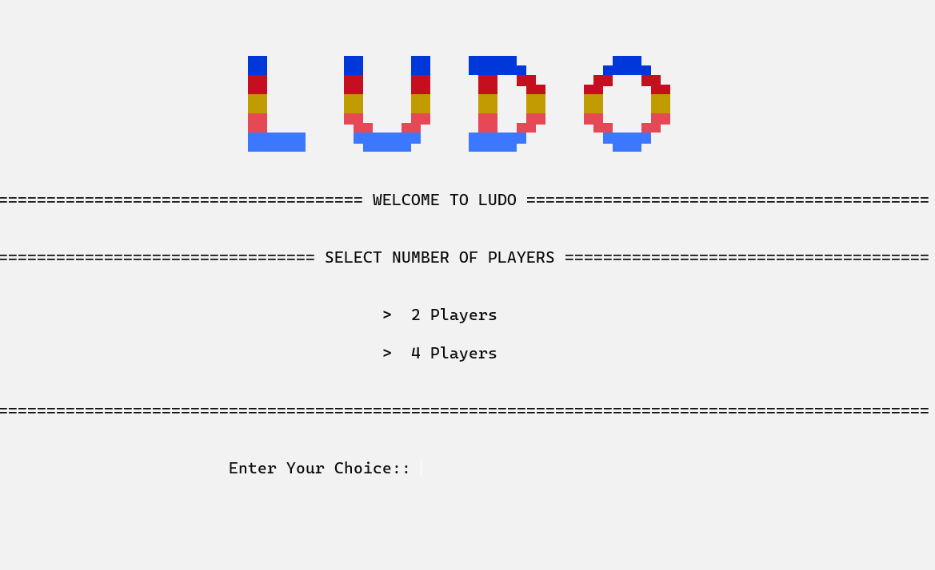

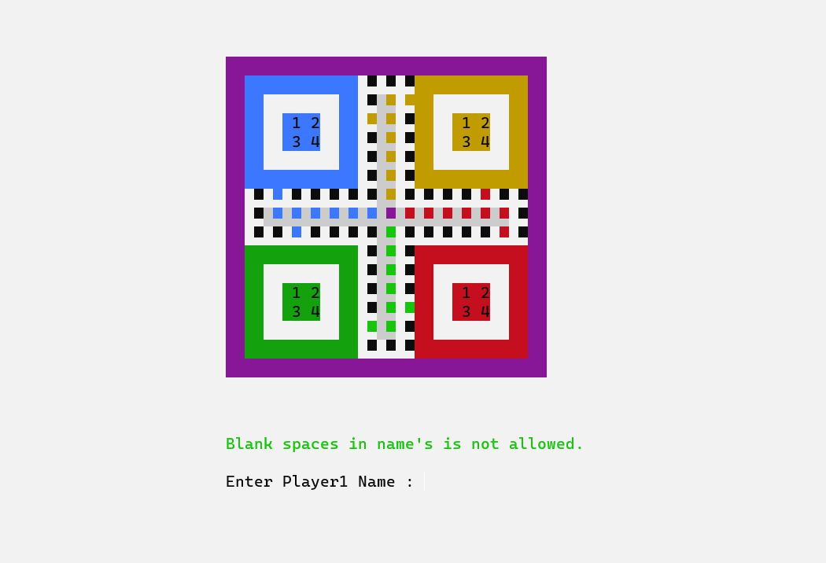

CONCLUSION:
The code successfully implements a basic Ludo game that allows multiple players to take turns rolling dice and moving their pieces around the board. The output demonstrates that players can roll the dice, and their movements are accurately reflected on the game board, with the game correctly identifying when a player has reached the finish line and won the game.

